1. In Replica set all pod have 1 PV whereas StatefulSets all will have own pvc.

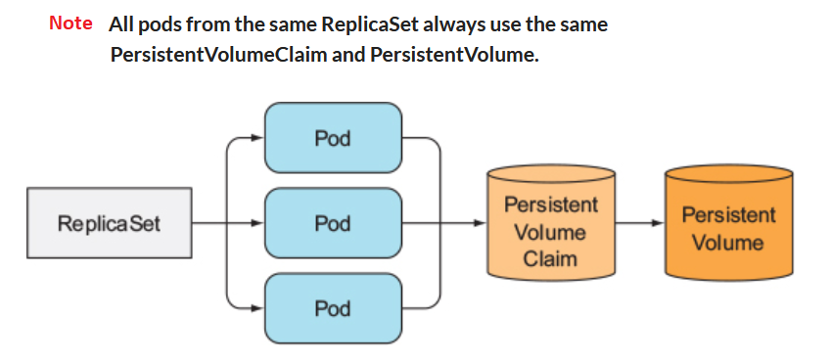

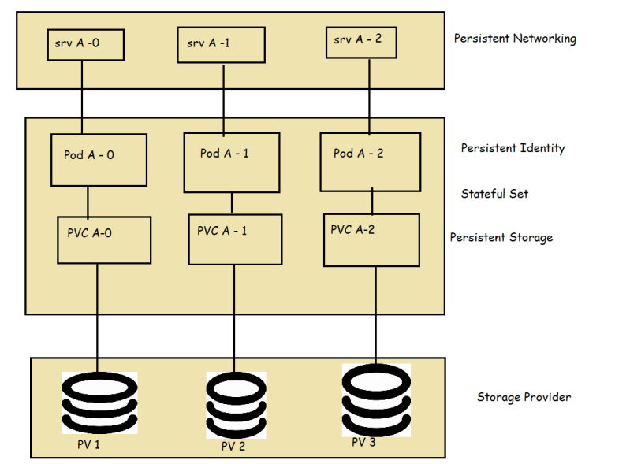

1. All application wants to sync each other replica set whereas no sync needed in stateful sets.

